**Lab 2 2 %**

**Due September 28, 2017 midnight via Blearn**

# Using ORACLE server 12c SQL*Developer (client)

Use your Oracle USER ID on BTACS database.

**Part 1 Time exercise**

1. Oracle supports the following datetime types: DATE, TIMESTAMP, TIMESTAMP WITH TIME ZONE, and TIMESTAMP WITH LOCAL TIME ZONE.

**DATE** stores date and time (both) to the second.

**TIMESTAMP** stores date and time (both) to the nanosecond (precision of up to nine digits) (supported since Oracle 9i).

**SYSDATE** function returnsthe date/time from the server stored as a DATE datatype

**SYSTIMESTAMP** function returnsthe current date/time/ zone offset from the server stored as a TIMESTAMP WITH TIME ZONE datatype

**CURRENT_DATE** function returns the current date and time of the current SQL session (client session) stored (or set by the user using ALTER SESSION. statement) stored as DATE datatype

**CURRENT_TIMESTAMP** function returns a TIMESTAMP WITH TIME ZONE value for the current SQL session (client session).

1. Display the current date/time (with the nanoseconds) from the server. Do **not** convert the datetime format into char (use default formatting). Explain (describe) each part of the result:

**SELECT SYSTIMESTAMP FROM DUAL;**



* **28-SEP-17** is the date
* **09.35.14.638785000** is the time showed as Hour : Minutes : Seconds : Nanoseconds
* **AM –** 12 hr format for morning times
* **-7:00** is the time zone offset from UTC time

1. Display current time (ISO standard) on the server include the fraction of seconds with the precision to 3 digits (milliseconds). The formatting for fraction is FF[1..9] For example: format 'HH24:MI:SS.FF2' 18:05:35.29

**SELECT to_char (SYSTIMESTAMP,'HH24: MI: SS.FF3’) FROM DUAL;**



1. The snippet below show a list of date/time 16 functions in Oracle taken from TechontheNet (totn)

<https://www.techonthenet.com/oracle/functions/extract.php>

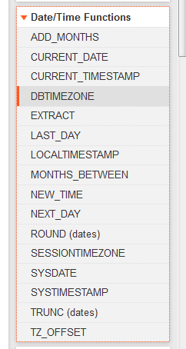

Use the tutorials to learn how to use EXTRACT function (note: the syntax uses BNF-like notation). Use the tables and data **BOOKS, PATRONS, TRANSACTIONS** from Lab 1 to do the following. Use the EXTRACT function to:

* 1. List the transactions (borrowing and returning books) done this month (use SYSDATE for current month). List transaction id and transaction date sorted by date.

Note: This SELECT statement needs a WHERE clause

**SELECT transaction_id, transaction_date**

**FROM transactions**

**WHERE (EXTRACT (MONTH FROM transaction_date) =**

**EXTRACT (MONTH FROM SYSDATE) AND**

**EXTRACT (YEAR FROM transaction_date) =**

**EXTRACT (YEAR FROM SYSDATE)) ORDER BY transaction_date;**

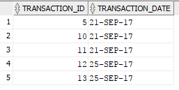

**FULL TABLE:**

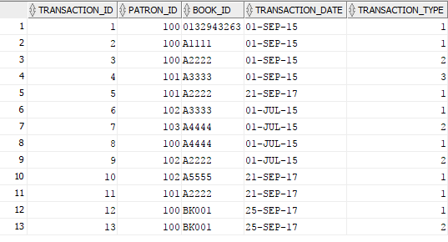

**Part 2 Script for the “Oracle 11g SQL” book by Joan Casteel**

**IMPORTANT:**

LAB 1 uses tables: books, patrons, transactions. The Oracle 11g book uses also books table. The solution is to rename the tutorial tables to L1_

**Oracle has a command to rename table to a new name:**

RENAME oldtablename TO newtablename; (SQL book p.79)

**RENAME books TO L1_books;**

**RENAME patrons TO L1_patrons;**

**RENAME transactions TO L1_transactions;**

The following is a conceptual (ERD) model for the JustLee books company database used in the Oracle 11g SQL book (p.11).

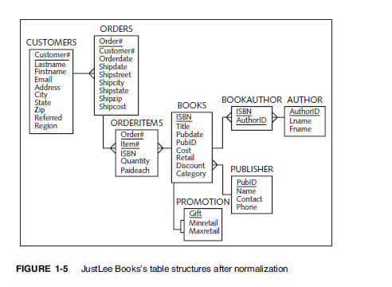

Run the script JLDB_Build_5.sql to create the tables and add data for the LustLee database. Please note that there is a statement to set the default for the date format. We are using the script from the Oracle SQL book; however, never use YY as year 🡪 use ISO standard. I’ve added the following

**ALTER SESSION SET NLS_DATE_FORMAT ='DD-MON-YY';**

Read chapter 2 and 3 4 from the Oracle 11g SQL book (available on reserve in Library)

1. List the names of the customers from California. List the Last name, the First name, and city. Add the aliases for the column names.

**SELECT lastname AS Last_Name, firstname AS First_Name, city AS Residence_City**

**FROM customers**

**WHERE state = 'CA';**

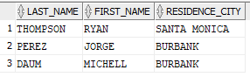

1. List the books (Book ISBN and title) from the “computer” category which were published before 2006. Use the function EXTRACT.

**SELECT isbn, title**

**FROM books**

**WHERE category = 'COMPUTER'**

**AND**

**EXTRACT (YEAR FROM pubdate) <2006;**

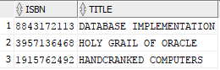

1. List the names (Last name space and the First name with a column alias) of the customers who have ordered books in March 2009. Use old or new syntax for the JOIN statement.

**SELECT lastname||' '||firstname AS customer_name**

**FROM customers JOIN orders ON orders.CUSTOMER# = customers.CUSTOMER#**

**WHERE EXTRACT (YEAR FROM orders.orderdate) = 2009**

**AND EXTRACT (MONTH FROM orders.orderdate) = 3;**

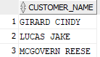

Results:

Customer Name

---------------------

GIRARD CINDY

LUCAS JAKE

MCGOVERN REESE

1. Add a column DOB to the customer table. Add a new customer whose name is Scarlett O’Hara (add all data for Scarlett including DOB ‘1844-07-01’). Write a select statement to list the customers born in 1844.

**ALTER TABLE customers**

**ADD (dob DATE);**

**INSERT INTO CUSTOMERS**

**VALUES (1021, 'SCARLETT', 'O ''HARA', 'P.O. BOX 5', 'HOUSTON', 'TX', '15007', NULL, 'S', 'sOhara@sat.net',to_date('1844-07-01','YYYY-MM-DD'));**

**SELECT customer#, lastname, firstname, dob FROM customers**

**WHERE EXTRACT (YEAR FROM dob) =1844;**



**Lab Submission**

Please submit pdf file with the SQL statements and the results (copy/paste/snip) from the SQLDeveloper.